**Q1.**

**What will happen when you attempt to compile and run the following code?**

**1. public class Test extends Thread{**

**2. public static void main(String argv[]){**

**3. Test t = new Test();**

**4. t.run();**

**5. t.start();**

**6. }**

**7. public void run(){**

**8. System.out.println("run-test");**

**9. }**

**10.}**

**Options are**

A.run-test run-test

B.run-test

C.Compilation fails due to an error on line 4

D.Compilation fails due to an error on line 7

**Q2.**

**What is the output for the below code ?**

**class A implements Runnable{**

**public void run(){**

**}**

**}**

**1. public class Test {**

**2. public static void main(String... args) {**

**3. A a = new A();**

**4. Thread t = new Thread(a);**

**5. t.start();**

**6. t.start();**

**7. }**

**8.}**

**Options are**

A.run-a

B.run-a run-a

C.Compilation fails with an error at line 6

D.Compilation succeed but Runtime Exception

**Q3.**

**What is the output for the below code?**

**import java.util.Iterator;**

**import java.util.TreeSet;**

**public class Test {**

**public static void main(String... args) {**

**TreeSet s1 = new TreeSet();**

**s1.add("one");**

**s1.add("two");**

**s1.add("three");**

**s1.add("one");**

**Iterator it = s1.iterator();**

**while (it.hasNext() ) {**

**System.out.print( it.next() + " " );**

**}**

**}**

**}**

**Options are**

A.one three two

B.Runtime Exception

C.one three two one

D.one two three

**Q4.**

**What will happen when you attempt to compile and run the following code ?**

**class A implements Runnable{**

**public void run(){**

**System.out.println("run-A");**

**}**

**}**

**1. public class Test {**

**2. public static void main(String argv[]){**

**3. A a = new A();**

**4. Thread t = new Thread(a);**

**5. System.out.println(t.isAlive());**

**6. t.start();**

**7. System.out.println(t.isAlive());**

**8. }**

**9. }**

**Options are**

A.false run-A true

B.false run-A false

C.true run-A true

D.Compilation fails due to an error on line 7

**Q5.**

**Thread priority in Java is?**

1. Integer
2. Float
3. double
4. long

**Q6.**

**What will be output of given code -**   
  
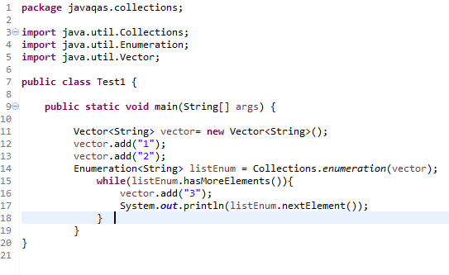

a. will execute without any exception   
b. (None of these)  
c. compilation error  
d. Throw ConcurrentModificationException

**Q7.**

**What will be output of following code -**   
  
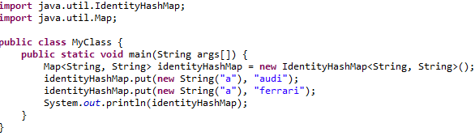

a. {a=ferrari}  
b. {a=audi, a=ferrari}  
c. Runtime Exception  
d. {a=audi}

**Q8.**

**What will be output of following code -**   
  
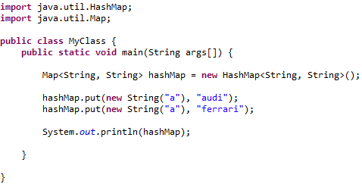

a. {a=ferrari}  
b. {a=audi, a=ferrari}  
c. {a=audi}  
d. null

**Q9.**

**What will be output of following code -**   
  
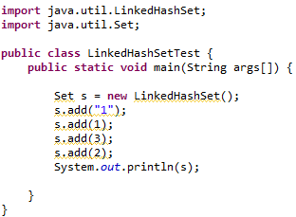

a. [1, 1, 2, 3]  
b. [1, 2, 2, 3]  
c. [1, 1, 3, 2]  
d. [1, 2, 3]

**Q10 .**

**How can Thread go from waiting to runnable state?**

a. notify/notifAll  
b. When sleep time is up  
c. Using resume() method when thread was suspended  
d. All